
Data Cleaning (Missing Values, Duplicates, Types)

🔹 Reminder
- Yesterday: we learned how to import & export data (CSV, Excel, JSON).
- Today: imported datasets are often messy → we must clean before analysis.

🔹 Why Cleaning Matters

Notes
- Garbage in = garbage out → ML models and visualizations are only as good as the data.
- Real-world issues:
  - Missing values → NaN (Not a Number).
  - Duplicates → repeated rows.
  - Wrong data types → e.g., numbers stored as text.
Use in Data Science
- Data cleaning can take 50–80% of project time.
- A well-cleaned dataset improves accuracy, reliability, and reproducibility.

🔹 Handling Missing Values

Practical
Check for missing values
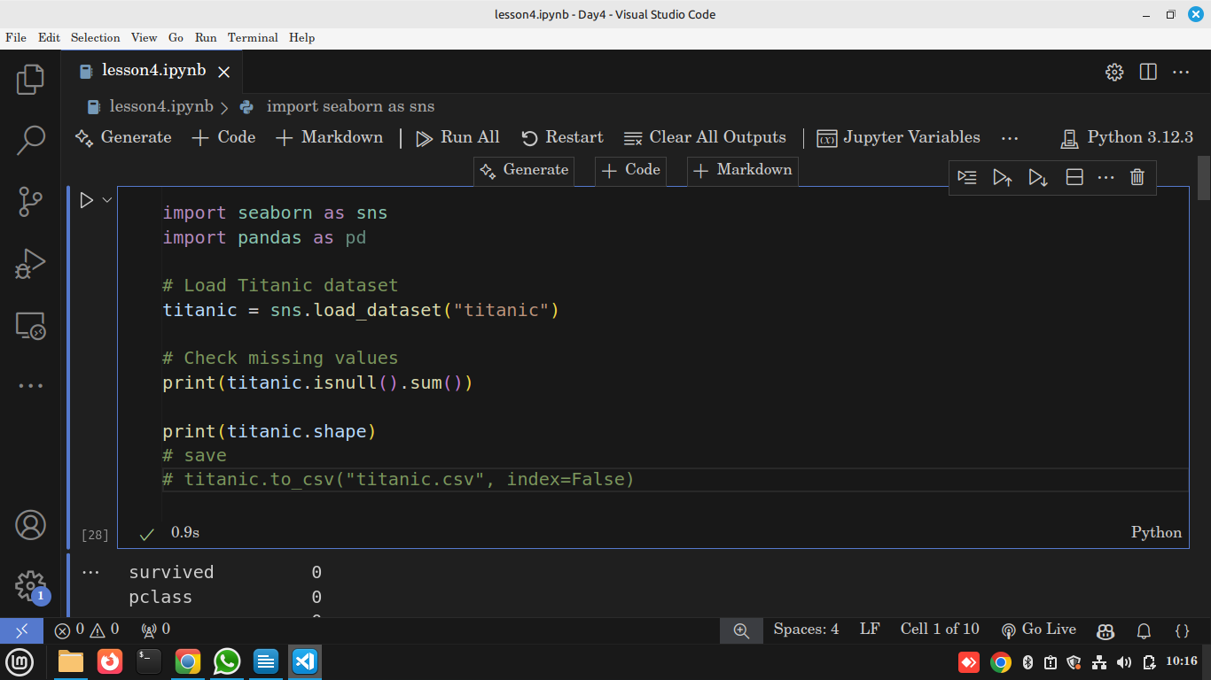
Output
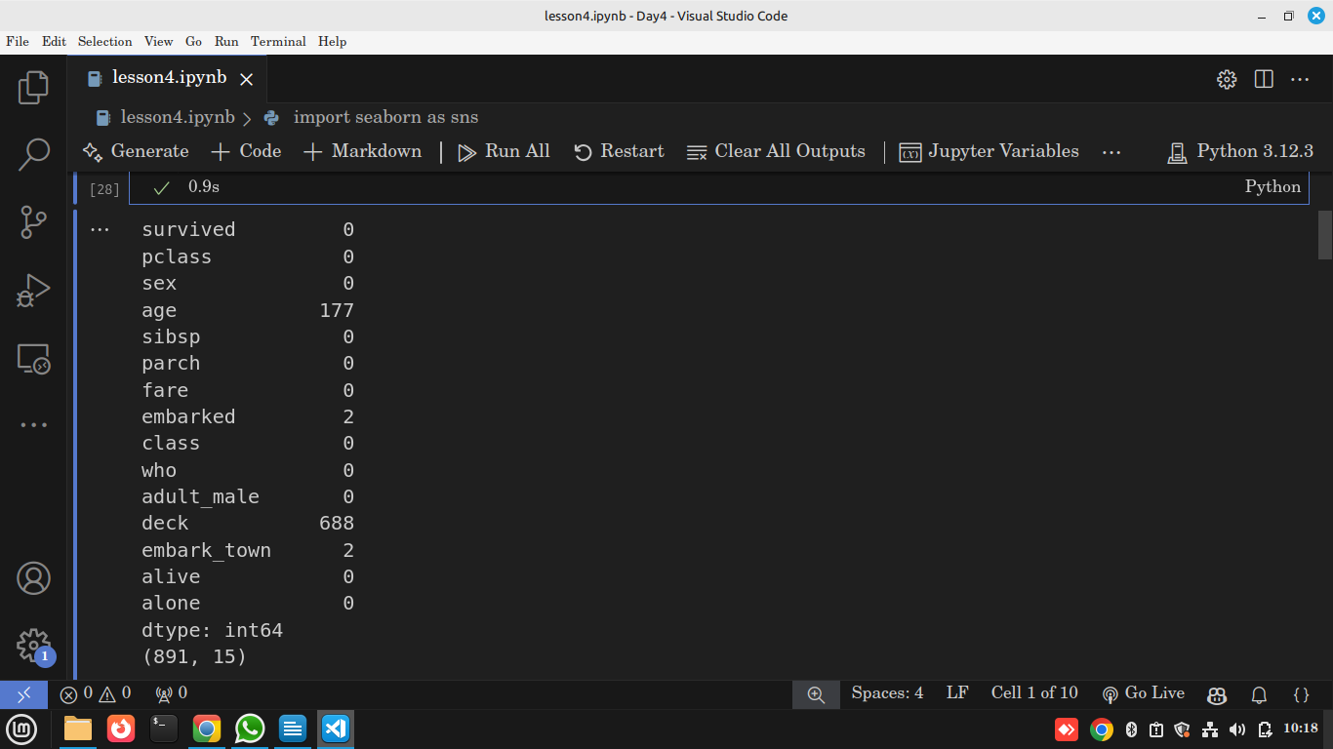

- We have some missing values in age ,deck, and embark_town
- we have a total of 891 rows and 15 columns

Option 1: Drop the empty rows
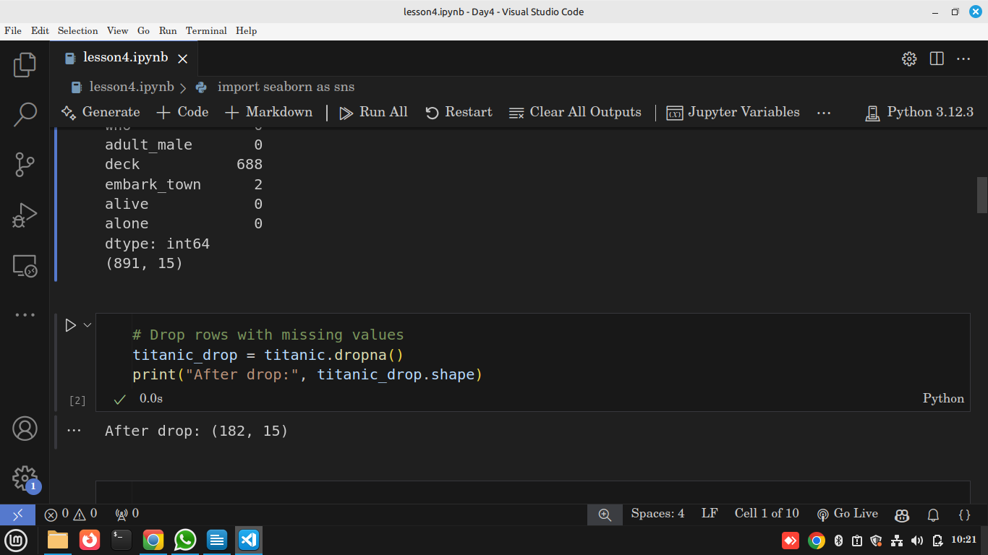
Option2 : Fill the missing values with Mean or Most common used value (mode)
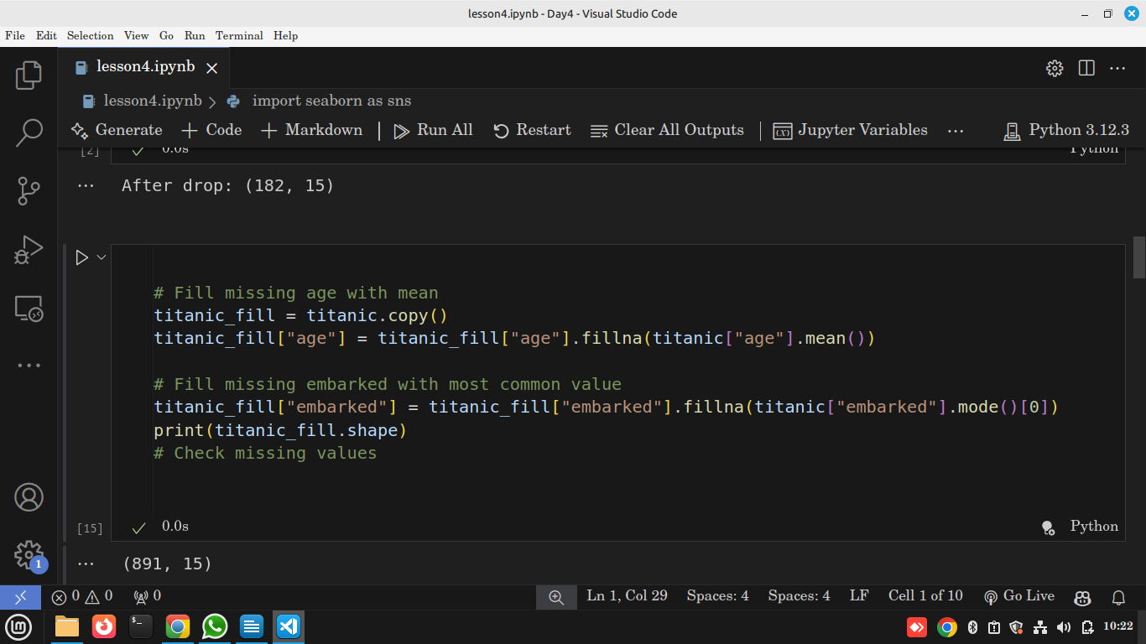
Explanation
- .isnull().sum() → counts missing values per column.
- .dropna() → removes rows with NaN.
- .fillna() → replaces missing values.
- .mode()[0] → fills with the most frequent category.
Use in Data Science
- Dropping vs filling depends on dataset size.
- Filling prevents data loss and makes models work.

🔹 Handling Duplicates

Practical
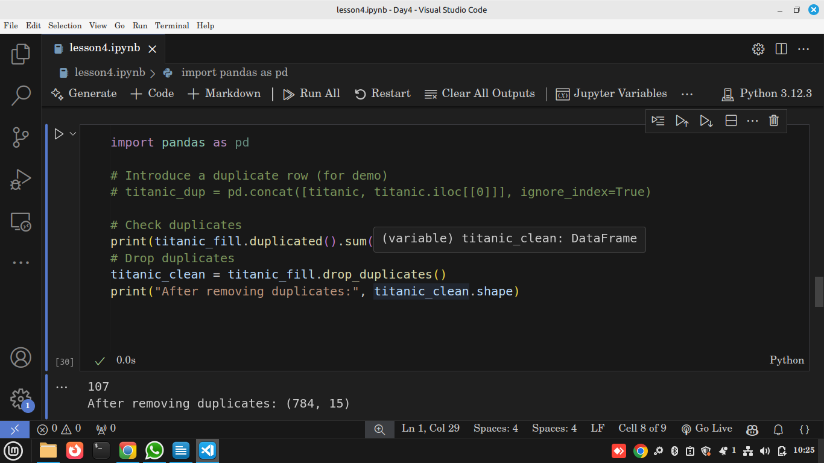
- .duplicated() → marks duplicates as True/False.
- .drop_duplicates() → removes them.
Use in Data Science
- Duplicates can bias results (e.g., same passenger counted twice).

🔹 Fixing Data Types

Practical
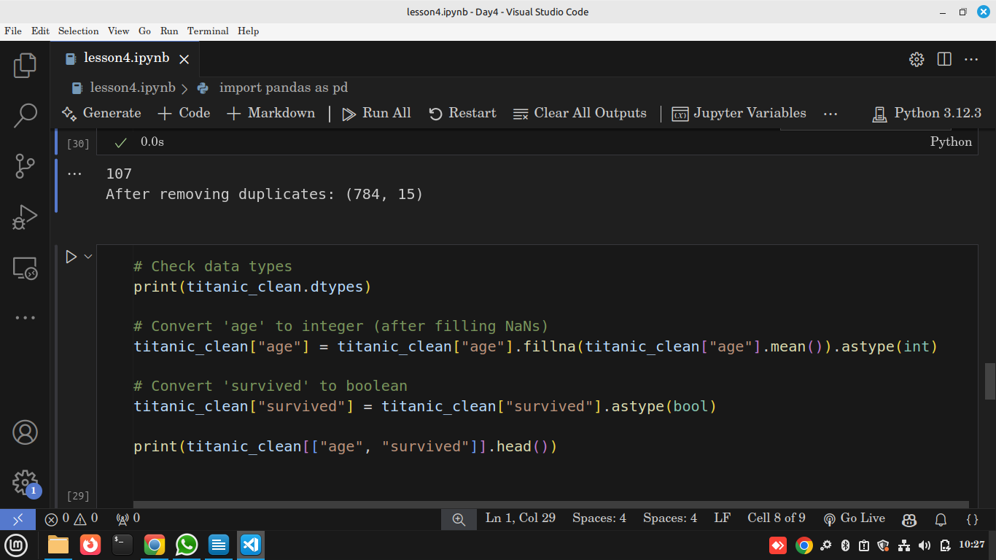

Output
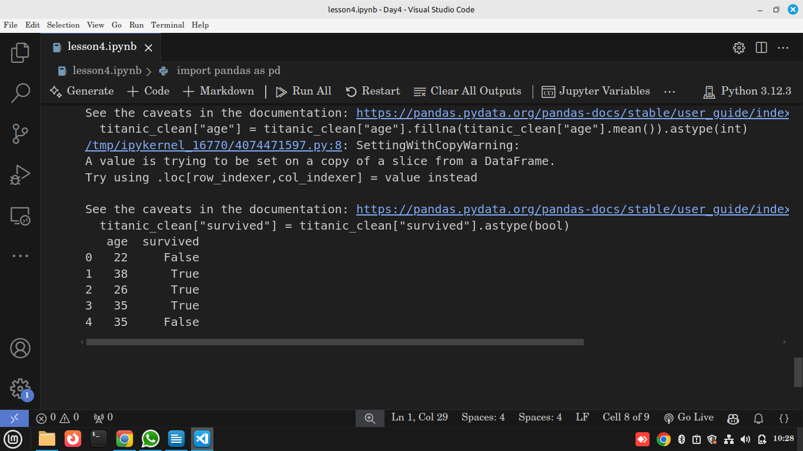

Explanation
- .dtypes → shows column data types.
- .astype(int) → ensures numerical consistency.
- .astype(bool) → makes survival easier to understand (True/False).
Use in Data Science
- Correct data types = fewer bugs + more efficient memory usage.

🔹 Mini Challenge
- On Titanic dataset:
  - Fill missing age with median instead of mean.
  - Drop duplicate rows.
  - Convert class column to category type.
  - Save cleaned dataset as titanic_clean.csv.

🔍 Reflection
- Why does cleaning take 80% of time?
- Would you always drop missing values?
- How does fixing data types help later in visualization & ML?

